# Flink job keep restarting

1. Check the alert **ads_infra_flink_job_restarts** in sherlock and see which job kept restarting

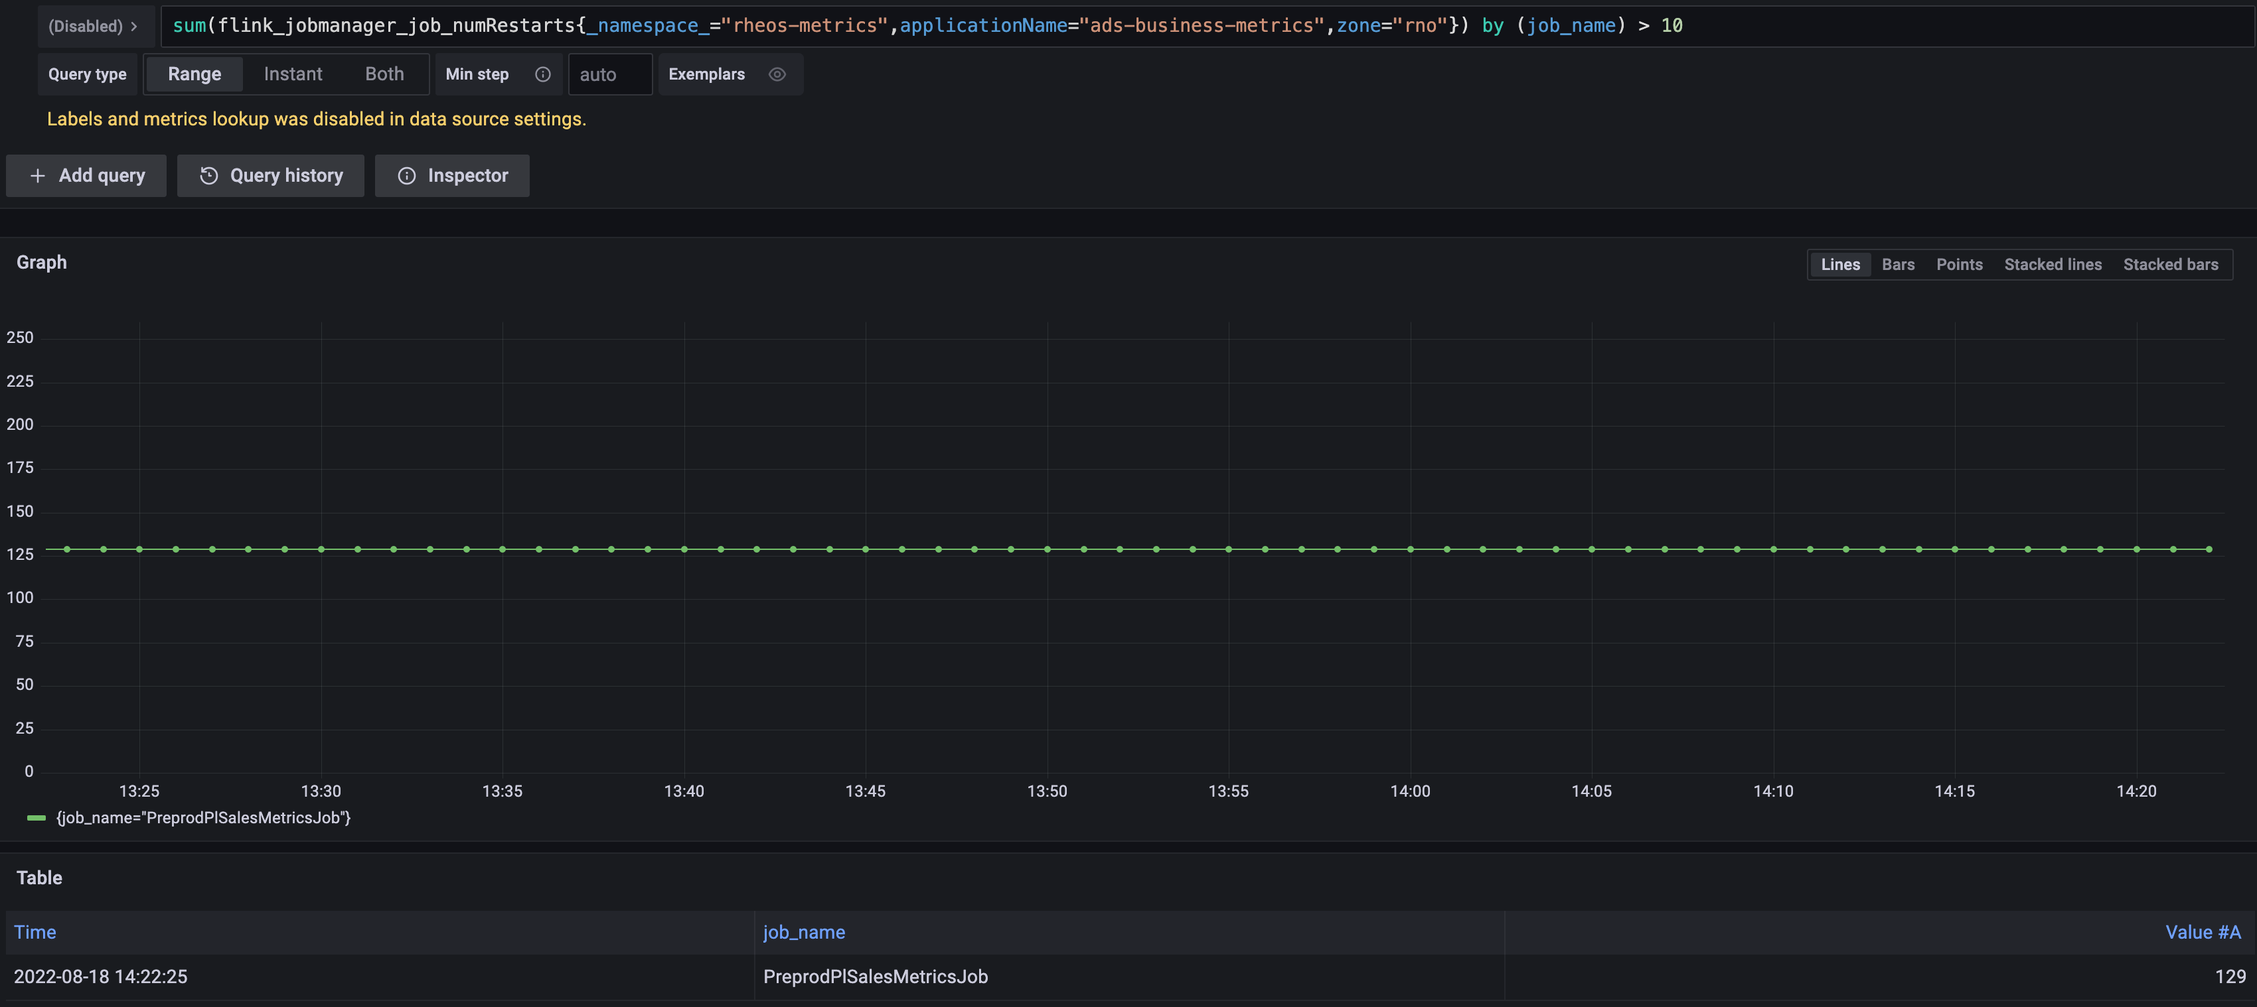

1. Find corresponding job in Rheos console: <https://rhs-portal.vip.ebay.com/flink/jobs>
2. Open monitor page in the job, and check if other metrics are abnormal.



1. Open the Flink UI page, and in running jobs tab, find the corresponding job
2. In Exceptions tab, check the root exception (usually a job restarts when exception happened)

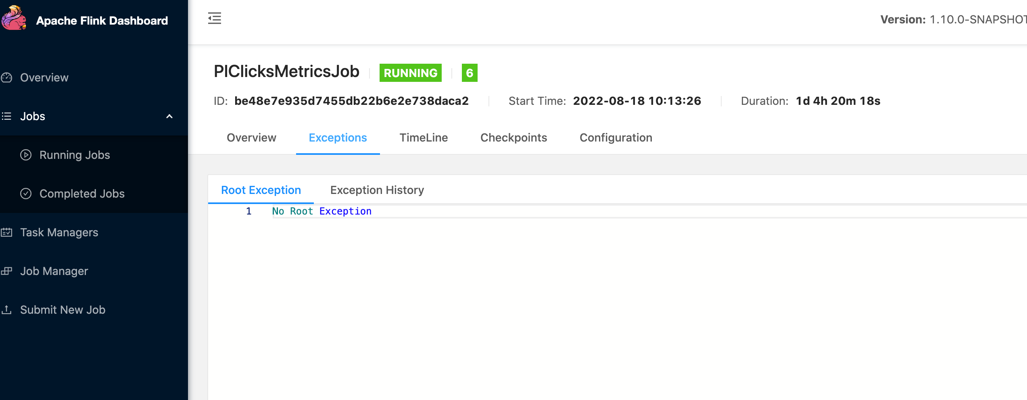

1. If the exception happened in the source stage (decode related), usually it is caused by upstream schema change.
   1. Check the schema in Rheos, like below:

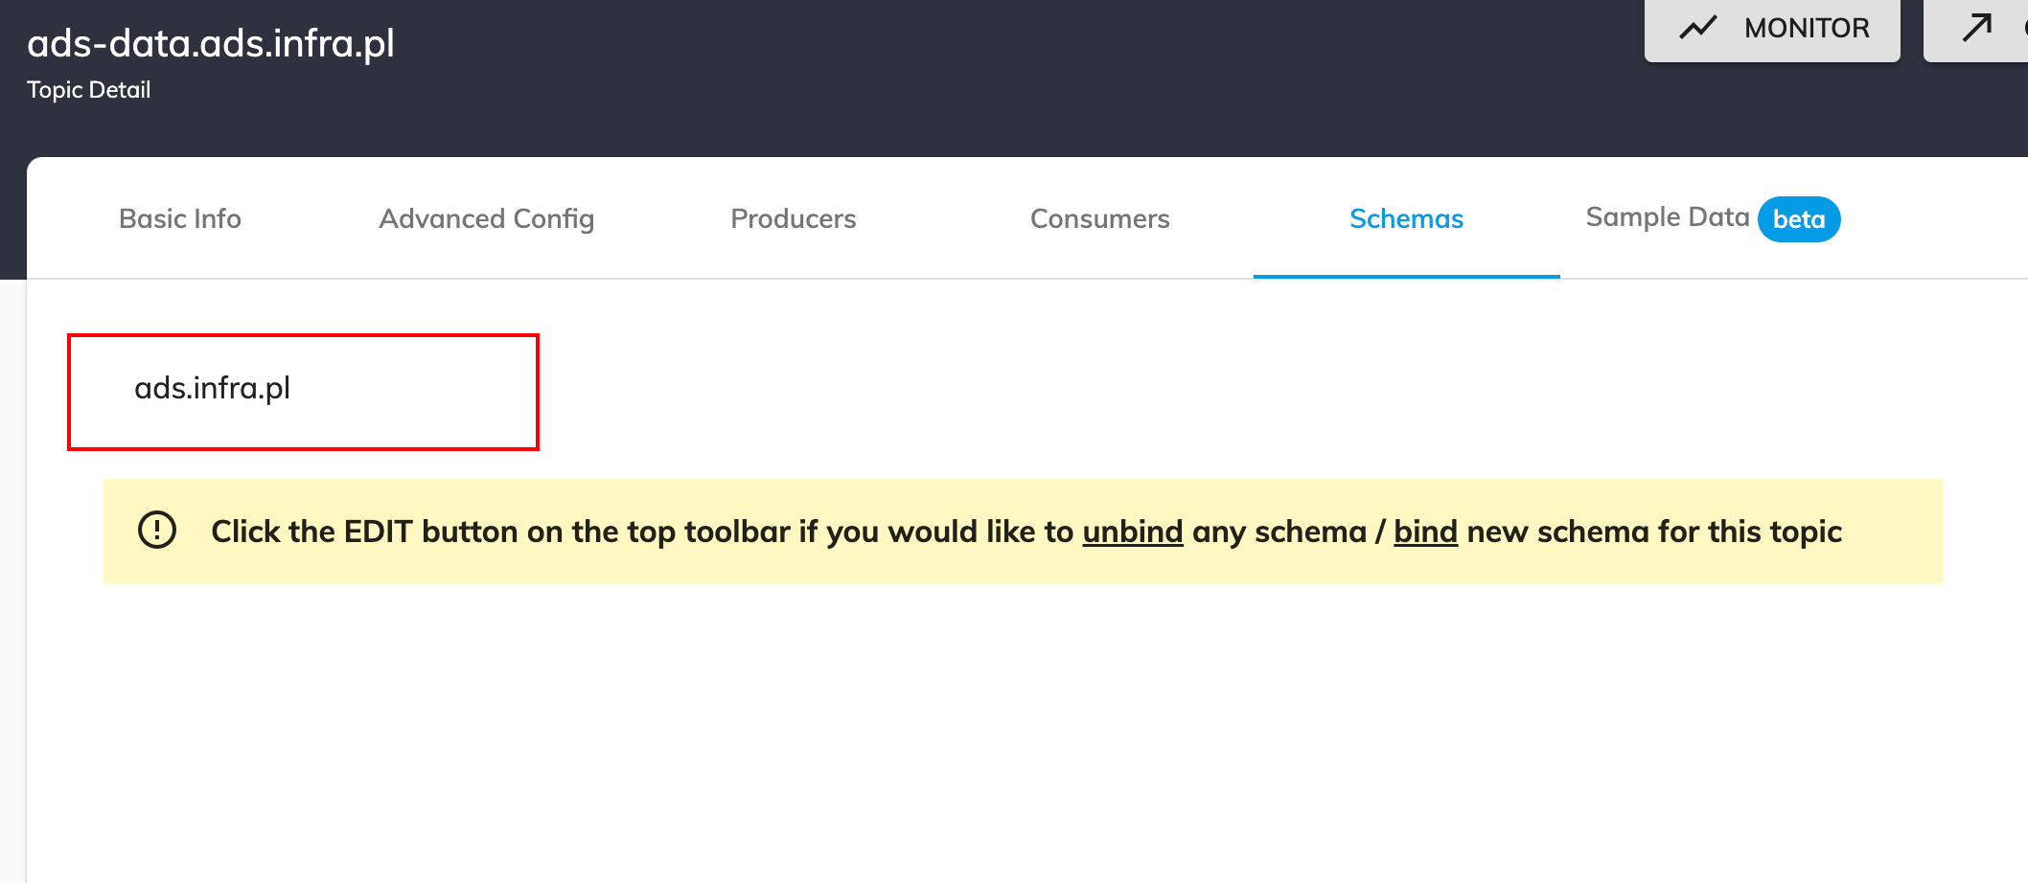

* 1. Compare the Rheos schema with the one in our Flink job code: <https://github.corp.ebay.com/adsinfra/ads-business-metrics-job/tree/master/src/main/avro>
  2. If the two schema are different, update the avro schema in the code, and build/deploy the new jar package, following this [guide](https://wiki.vip.corp.ebay.com/display/AdsInfra/Flink+job+deployment)